Simple car recipe

Contents

Setup a simple car 1

Play 7

# Setup a simple car

1. Add a part – >block of size (14,1,7), set position to (-4,0.5,-20). This will be chassis of car.
2. Ensure model->move is checked with 0.1 studs.
3. Add another part->block of size(1,1,1) and set position to (-10.5, 0.5, -16), duplicate this and put it on other side (back left) as shown in image below.
4. A map of the state of indiana

   Description automatically generated
5. Now duplicate the small parts and take it to front part. See image below.
6. 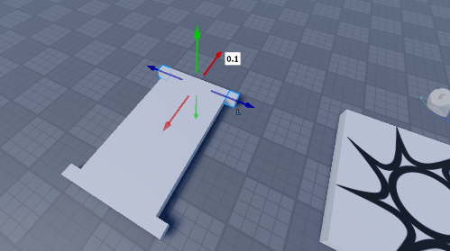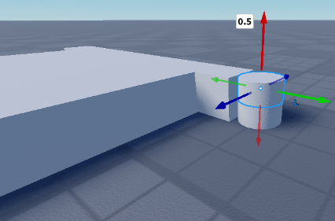A computer generated image of a white cube

   Description automatically generated
7. Now add a part->cylinder or size(1,1,1) and position (2.5,0.5,-16). Now slowly pull it out so that it just touches the small cube. And scale along ‘y’ axis to 0.5. Duplicate the cylinder and move it above the current one. Duplicate the small cube and move it along ‘z-axis’ so that it just touches the two cylinders. See images above.
8. Duplicate the cylinder and outer small cube and take it to other side also. See image below.
9. 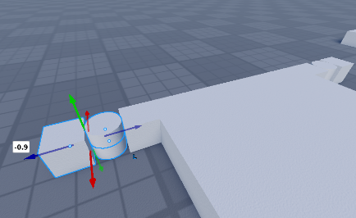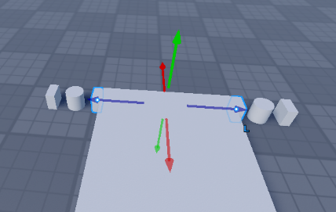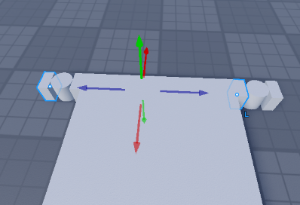
10. Make the width of front small cubes to 0.5 using scale tool. See image above. The move them together such that they touch each other see image above.
11. Add cylinder of size (1,4,4) and rotate it so that orientation is (0,90,0) – this will be used as wheel. And position at (2.5, 0.5, -14). See image below.
12. A white object on a grey surface

    Description automatically generated
13. Make the width of 2 small cubes at the back to 2 units by scale tool. See image below.
14. A screenshot of a video game

    Description automatically generatedA computer generated image of a machine

    Description automatically generated
15. Duplicate the wheel to 3 mores positions as shown above. The back right wheel’s position is (-10.5, 0.5, -14). Back left wheel position at (-10.5, 0.5, -26) and Front left wheel position at (2.5, 0.5, -26). See image above.
16. Now select all parts and move everyone up so that the wheel touches the ground.
17. A screenshot of a computer generated image

    Description automatically generated
18. Select the big box, 2 small back boxes and 2 front small boxes and 2 half cylinders, below ones, total of 7 parts and make it union and rename to chassis. See below.
19. A screenshot of a computer generated image

    Description automatically generated A white round objects with blue arrows

    Description automatically generated
20. Select upper cylinder and small half cube next to it, do union and rename it ‘SteerFrontRight’. See image above. Similarly do for left to make ‘StreeFrontLeft’.
21. Now move each wheel 3 studs away and SteerFrontRight and SteerFrontLeft move up by 2 studs, this is so that we can create the hinges. See image below.
22. A white object with wheels

    Description automatically generated with medium confidence
23. Now create a hinge constraint between back right wheel and opposite small face of the chassis. Start from wheel to the small face. Make sure both the attachment points are at center. Rename to ‘WheelConstraint’.
24. A screenshot of a video game

    Description automatically generated
25. Similarly for the back left wheel.
26. Add a hinge constraint for SteerFrontRight, start at the top to bottom circular face of chassis. Rename to ‘SteerConstraint’. See image.
27. A screenshot of a video game

    Description automatically generated
28. Similarly, add a hinge constraint for StreerFrontLeft and the circular face on chassis also.
29. Now, move the SteerFrontRight and SteerFrontLeft back to their original positions (2 studs below), so that they are just above the circular bottom face of chassis.
30. A screenshot of a video game

    Description automatically generated
31. Now, similar to back right and back left wheels, add hinge constraint from front right wheel to the square face of SteerFrontRight and similarly for front left wheel and rename both to ‘WheelConstraint’.
32. A video game of a game

    Description automatically generated
33. Now, move all the wheels back to their positions.
34. Select both ‘SteerConstraint’ from explorer, and set actuator type to Servo. Set AngularResponsiveness to 45, Angularspeed to 10 and ServoMaxTorque to 10000.
35. Select all 4 ‘WheelConstriant’ in explorer, and set Actuator type to Motor. Angular velocity to 0, MotorMaxAcceleration to 500000 and MotorMaxTorque to 10000.
36. Rename the wheels to WBl, WBr, WFl, WFr (for back left, back right, front left and front right)
37. Right-click on the 3d view -> insert object -> select vehicle seat. Set position to (-2.6, 3, -20) and orientation to (0, -90, 0).
38. Select all car parts and hit ‘Ctrl+g’ to group as model and rename the groupd to ‘Car’
39. A screenshot of a game

    Description automatically generated
40. Using the ‘+’ symbol next to car add a ‘weld constraint’
41. In the settings of weld constraint make part0 to be chassis and part1 to be vehicle seat
42. A screenshot of a computer

    Description automatically generated

# Play

1. Play and see.
2. Gamer must be able to jump into the black seat and drive and steer the car using ‘w’,’a’,’s’ and ‘d’.